Weather explains interannual variability, but not the temporal decline, in insect biomass

François Duchenne*1

*1Swiss Federal Institute for Forest, Snow and Landscape Research (WSL),* *8903 Birmensdorf, Switzerland*

[francois.duchenne@wsl.ch](mailto:francois.duchenne@wsl.ch)

*: corresponding author, [francois.duchenne@wsl.ch](mailto:francois.duchenne@wsl.ch%20)

ARISING FROM J. Müller et al. *Nature* <https://doi.org/10.1038/s41586-021-03871-y> (2023)

**Competing interests statement:**

The author declares no competing interests.

**Author contributions:**

FD performed the analyses and did the figures and wrote the manuscript.

**Code availability statement:**

The R code to perform the analyses are provided as supplementary material.

**Data availability statement:**

The data are available with the original publication, <https://doi.org/10.1038/s41586-021-03871-y>.

# Main

In a recent publication1, Müller *et al.* re-analysed, in light of new data, the dataset of the highly cited paper of Hallmann *et al.*2, who showed a strong decline in insect biomass in Germany between 1989 and 2016. Müller *et al.* first show that adding recently collected data (2016-2022) to Hallmann *et al.* time series, results in a non-significant decline in biomass between 1989 and 2022. Second, they present a re-analysis of the data from Hallmann *et al.* adding weather conditions as predictors and conclude that the temporal variations in insect biomass are explained by weather conditions only. Here I show that their methodological approach is unsuitable to draw such conclusions, because of the limitations of the dataset and because of flawed statistical analyses. More appropriate analyses produce a pattern opposite to the main message of Müller *et al.*: there is a significant temporal decline in insect biomass that is not explained by weather conditions.

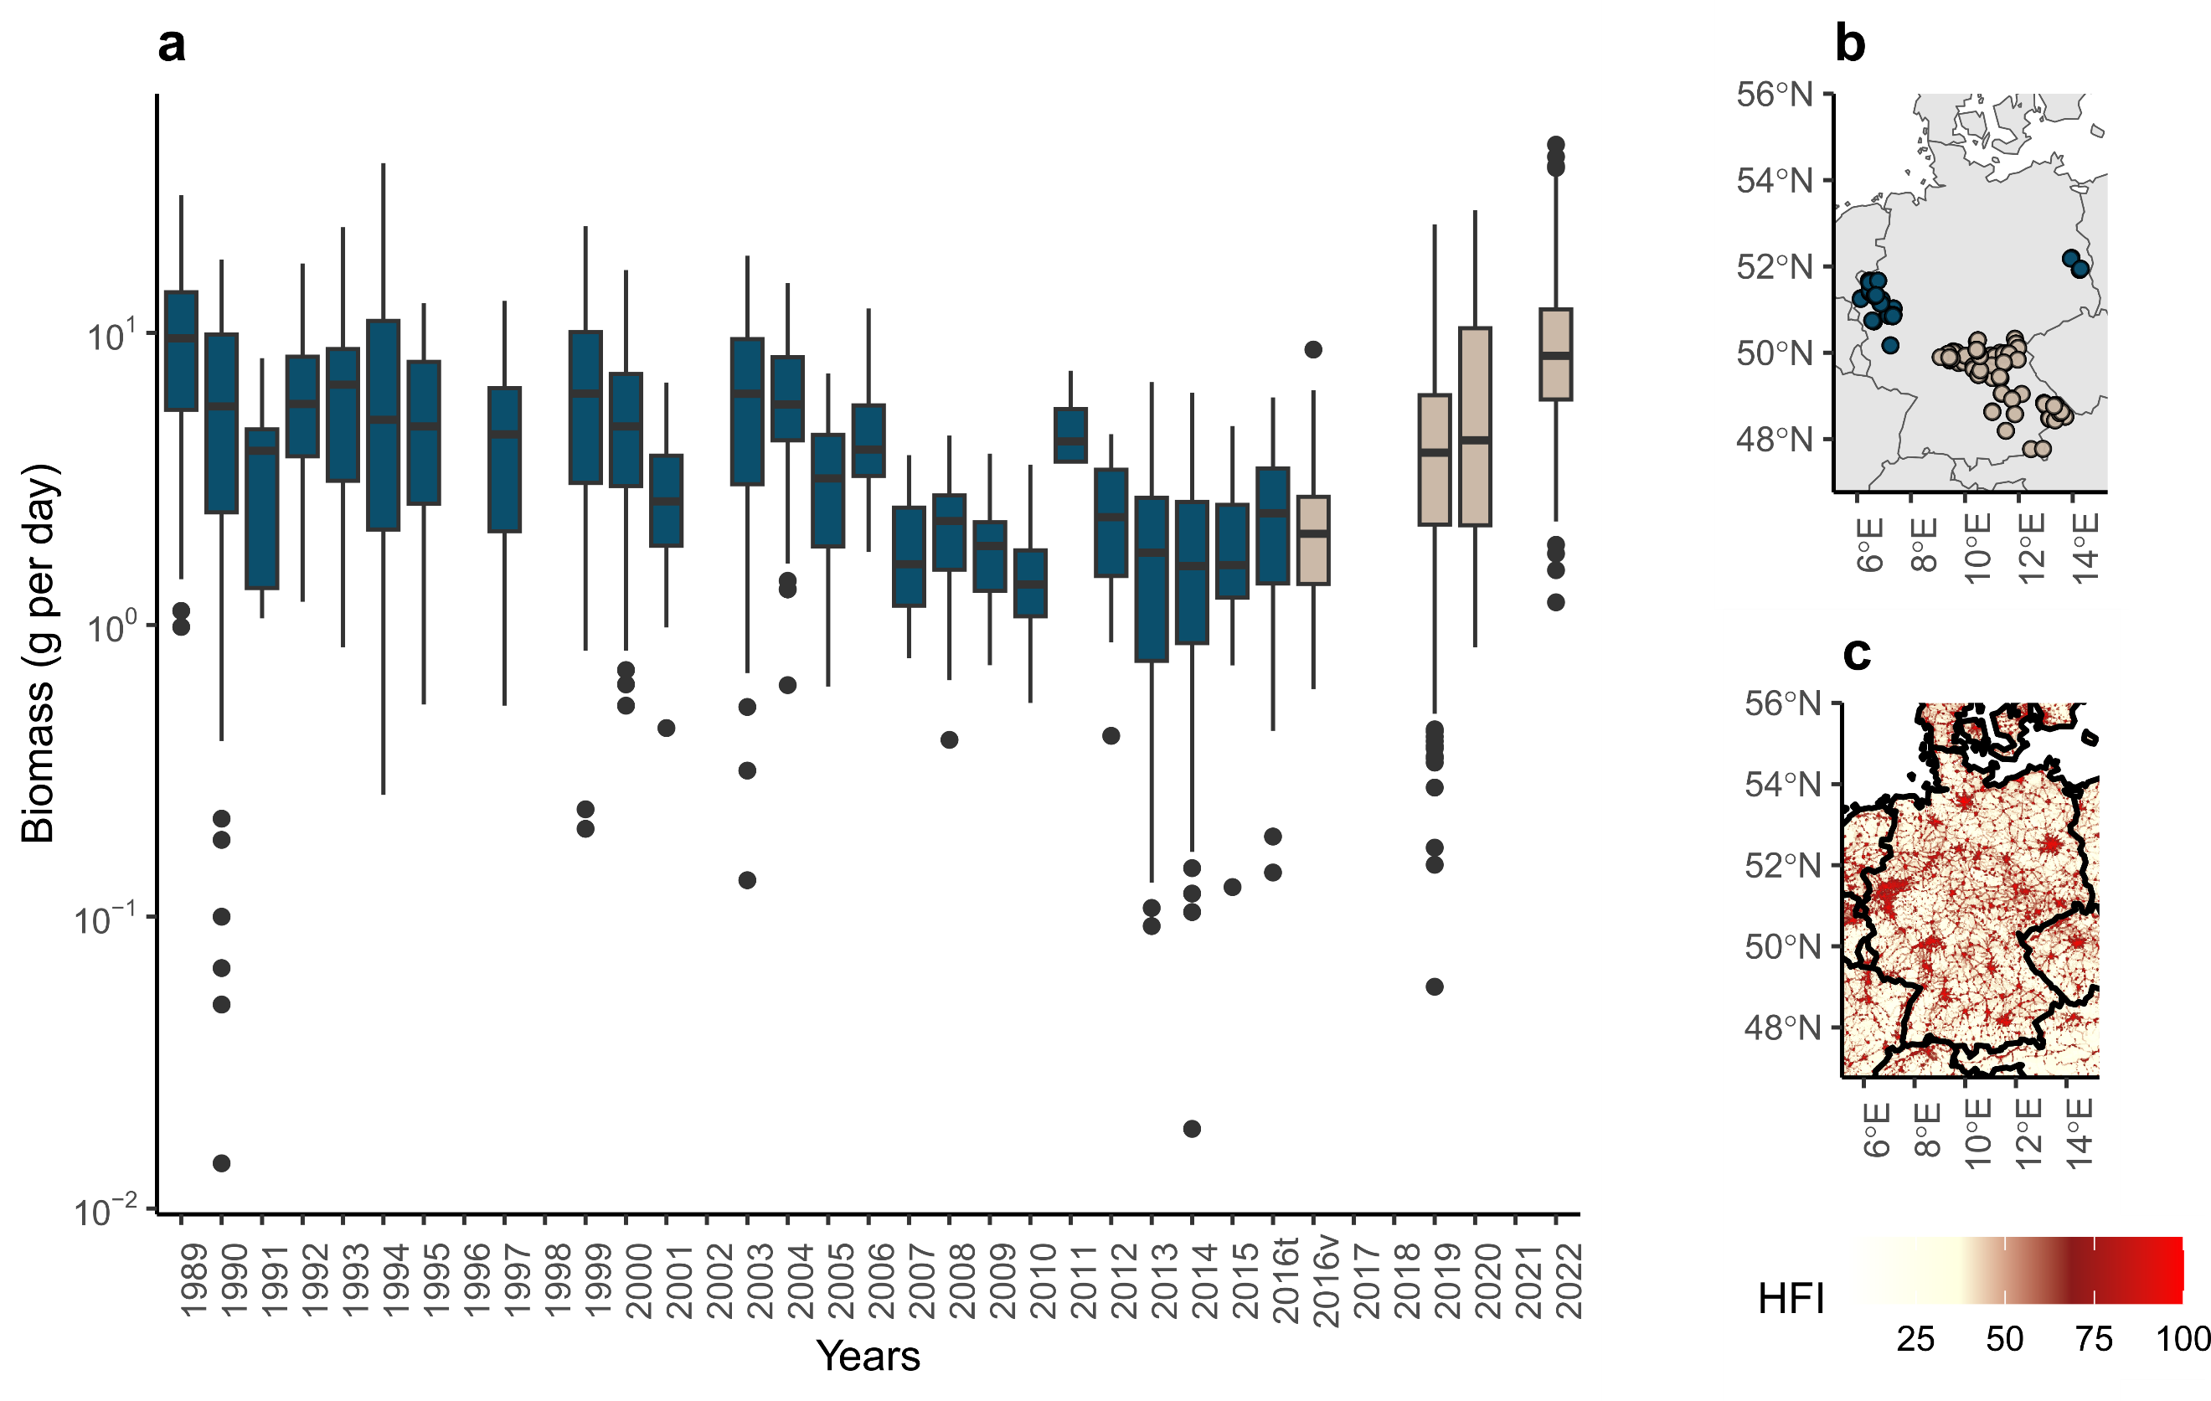First, figure 1 of Müller *et al.* is misleading because it exhibits two datasets collected on different geographic areas, as shown by their Extended Data Fig. 1, as a unique time series. The 1989-2016 data used by Müller *et al.* to fit their model, were mostly collected in middle-west Germany, while the 2016-2022 data, used to validate the model, were collected in south-east Germany (Fig. 1). Thus, Figure 1 of Müller *et al.* provides biomass values that should not be compared with each other without accounting for spatial differences. Areas in which the data of Hallmann *et al.* were collected are more anthropized than the areas in which recent data were collected (Fig. 1b-c). This difference alone could explain the apparent increase in insect biomass in recent data. However, the authors take few precautions to interpret this heterogeneous time series: “*The temporal pattern of the compiled data shows that the linear decrease reported by Hallmann et al. throughout 2016 did not continue in more recent years, but instead biomass increased from 2016 until 2022, with highest values similar to those from the late 1980s reached in 2022 (Fig. 1).”.*

***Fig. 1: Misleading presentation of the initial and new datasets for insect biomass.*** *Data from Hallmann et al. (blue, training dataset in Müller et al.) and more recently collected data (beige, validation dataset in Müller et al.) were presented by Müller et al. on the same time series (a), while they were collected in different geographic areas (b). In (c) I represented the Human Footprint Index (HFI, v2 1995-2004).*

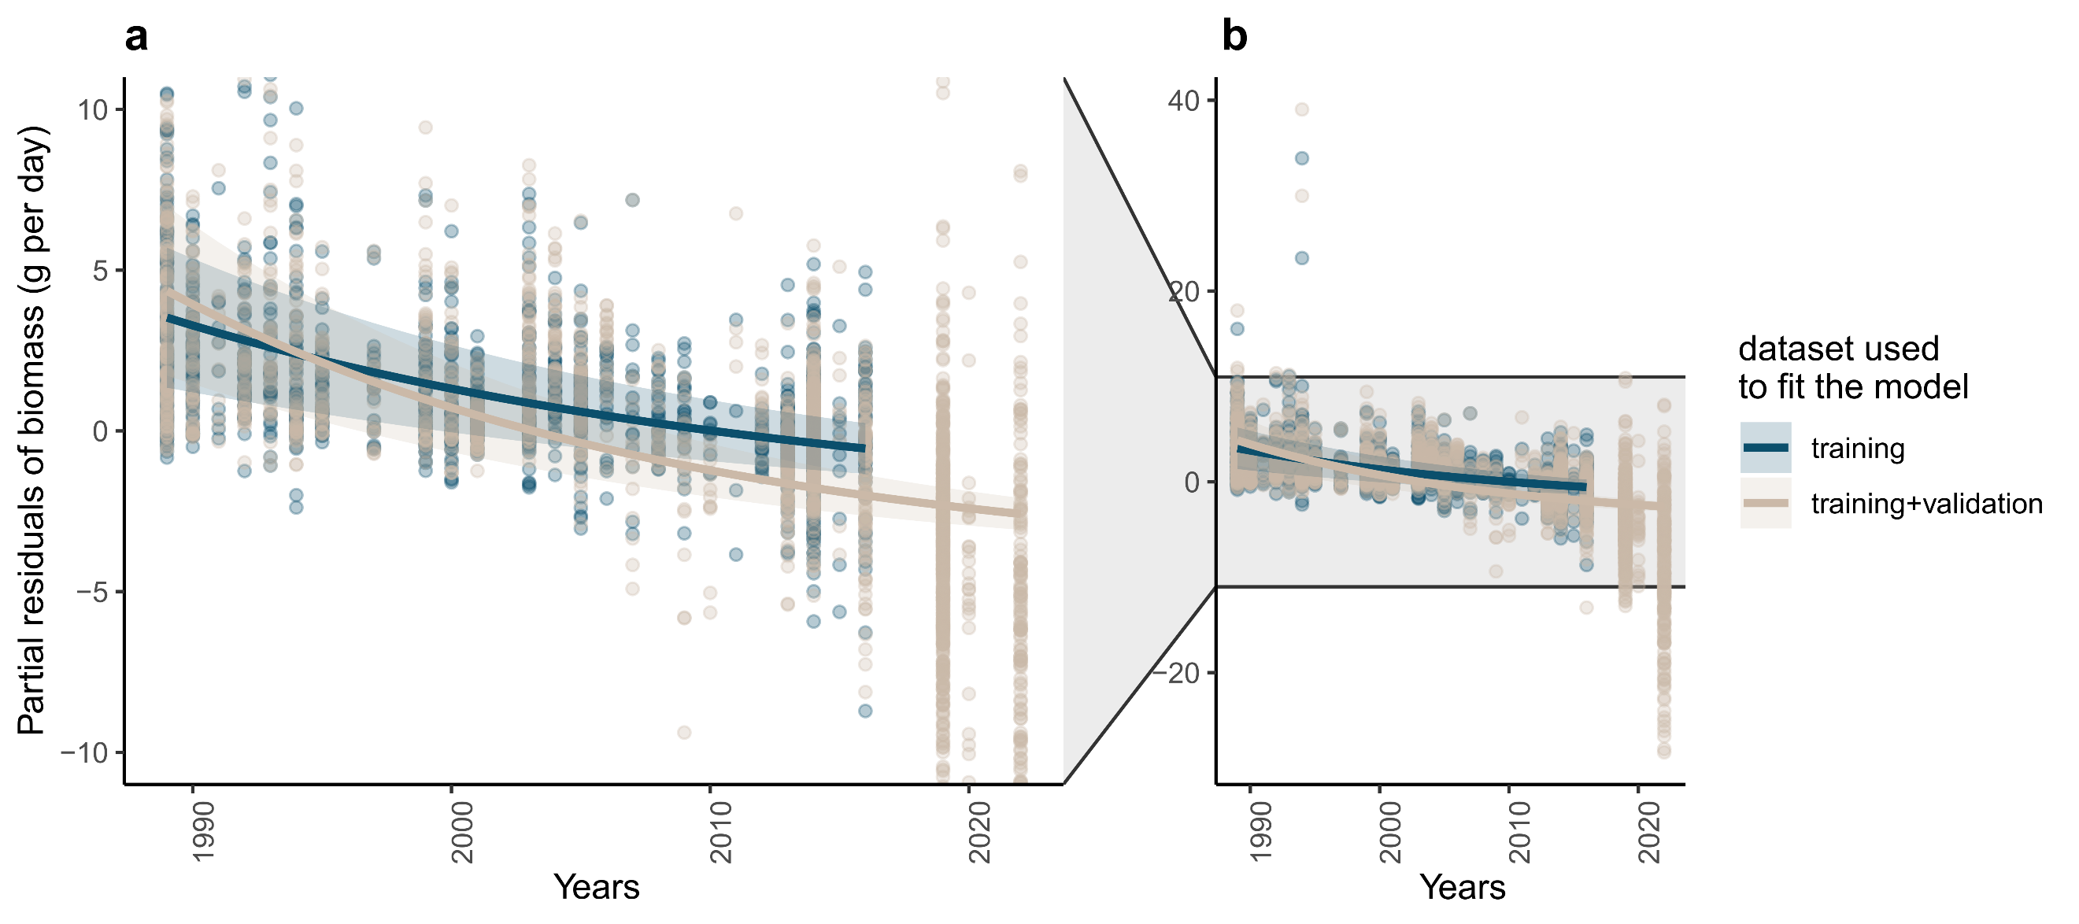Second, the authors claimed to show that weather conditions are the main drivers of the temporal changes in insect biomass, whereas temporal changes in habitat conditions played a minor role only. However, their analyses only show that weather conditions strongly affect inter-annual variability in insect abundance, which is well known3–7, but their methods are not suited to assess the relative contributions of weather *vs.* land use change in long-term temporal changes (*i.e.* average decline). In their statistical analyses, habitat was modelled as a constant variable, varying only across sites, not in time. Thus, the authors modelled the effect of habitat, but not the effect of temporal change in habitat conditions, on insect biomass. The conclusion “*temporal changes in habitat conditions played only a minor role*” in the temporal changes of insect biomass, is therefore surprising and unwarranted, because this role was not assessed. Such kind of illegitimate conclusions, minimizing the contribution of land use change in the long-term trend of insect biomass, can be strongly deleterious for biodiversity conservation.

***Fig. 2: The temporal trend in insect biomass is significantly negative when the effects of weather are accounted for.*** *Panel (a) is a zoom on the y-axis of panel (b), to improve readability, which is reduced by outliers. Both panels show the partial residuals of biomass, i.e. the amount of biomass not explained by other predictors, as a function of year, when using the training dataset only (blue, from Hallmann et al., 1989-2016) or the training and validation datasets together (beige, 1989-2022), to fit the model. Lines and ribbons show the model prediction and its 95% confidence interval.*

Third, Müller *et al.* argue that weather conditions were the only driver of temporal changes in insect biomass, because when weather conditions were included in their model, there was no remaining temporal trend in the residuals of the model (model 5 of their study). However, this hierarchical approach is highly biased: the model first absorbs all the variation possible with weather data before the authors look for a remaining temporal trend. Since there is a known temporal trend in weather conditions themselves (aka climate change), the statistical fit, which seeks to explain as much variance as possible with the available variables, is likely to attribute any temporal change in insect biomass to temporal changes in weather conditions. Thus, the absence of temporal trend in the residuals is not informative on the importance of non-modelled drivers. In contrast, when I estimated both a temporal trend in insect biomass and the effects of weather conditions simultaneously, by simply adding a linear year effect to Müller et al.’s model, I found opposite results, while improving the fit of the model (lower AIC, Table 1). I estimated a significant decline of biomass over time (-4.0%.year-1) that was not explained by weather conditions (Fig. 2 and Table 1).

***Table 1: Model estimates and goodness of fit for the model of Müller et al. and for the modified version, with an additional linear year effect.***

|  |  |  |  |  |  |  |
| --- | --- | --- | --- | --- | --- | --- |
| Variable | Model 5 from Müller et al. | | | Modified model 5 | | |
| Estimate | Stde | p-value | Estimate | Stde | p-value |
| Number of herb species | 0.0008 | 0.0011 | 0.4763 | -0.0022 | 0.0011 | **0.0377** |
| Number of tree species | 0.1174 | 0.0121 | **0.0000** | 0.0515 | 0.0143 | **0.0003** |
| Ellenberg value light | 0.1469 | 0.0646 | **0.0232** | 0.0529 | 0.0635 | 0.4051 |
| Ellenberg value temperature | -0.0351 | 0.0406 | 0.3867 | 0.0702 | 0.0408 | 0.0857 |
| Proportion of arable land | -0.3530 | 0.1108 | **0.0015** | -0.0808 | 0.1130 | 0.4746 |
| Proportion of forest | -0.1493 | 0.1139 | 0.1899 | 0.0630 | 0.1139 | 0.5803 |
| Proportion of grassland | 0.3484 | 0.1161 | **0.0027** | 0.2487 | 0.1129 | **0.0277** |
| Proportion of water | 0.2816 | 0.1479 | 0.0571 | 0.0364 | 0.1448 | 0.8016 |
| \**T* | 0.0814 | 0.0062 | **0.0000** | 0.0844 | 0.0060 | **0.0000** |
| \**P* | -0.0033 | 0.0008 | **0.0000** | -0.0025 | 0.0007 | **0.0007** |
| \**T* × *P* | -0.0001 | 0.0002 | 0.7482 | 0.0000 | 0.0002 | 0.8560 |
| \**T* ano. winter | -0.2943 | 0.0268 | **0.0000** | -0.1232 | 0.0321 | **0.0001** |
| \**P* ano. winter | 0.0339 | 0.0026 | **0.0000** | 0.0197 | 0.0030 | **0.0000** |
| \**T* ano. winter × *P* ano. winter | -0.0114 | 0.0025 | **0.0000** | -0.0021 | 0.0026 | 0.4187 |
| \**T* ano. April cur | 0.0820 | 0.0261 | **0.0017** | 0.0810 | 0.0237 | **0.0007** |
| \**P* ano. April cur | 0.0148 | 0.0016 | **0.0000** | 0.0068 | 0.0017 | **0.0000** |
| \**T* ano. April cur × *P* ano. April cur | -0.0028 | 0.0009 | **0.0036** | -0.0003 | 0.0009 | 0.7761 |
| \**T* ano. April prev. | -0.1082 | 0.0303 | **0.0004** | 0.0155 | 0.0301 | 0.6073 |
| \**P* ano. April prev. | 0.0021 | 0.0015 | 0.1477 | 0.0028 | 0.0014 | **0.0405** |
| \**T* ano. April prev. × *P* ano. April prev. | -0.0044 | 0.0008 | **0.0000** | -0.0014 | 0.0008 | 0.0932 |
| \**T* ano. month prev. | -0.0078 | 0.0119 | 0.5135 | -0.0059 | 0.0117 | 0.6134 |
| \**P* ano. month prev. | -0.0009 | 0.0004 | **0.0369** | -0.0001 | 0.0004 | 0.7498 |
| \**T* ano. month prev. × *P* ano. month prev. | -0.0006 | 0.0003 | **0.0419** | -0.0001 | 0.0003 | 0.7196 |
| Year | not included | | | -0.0411 | 0.0048 | **0.0000** |
| R2 | 0.6543 | | | 0.6661 | | |
| AIC | 13156.2570 | | | 13101.6760 | | |

*T*, temperature; *P*, precipitation; ano., anomalies; cur, year of sampling; prev., the month of the sampling day but in the previous year; Stde, Standard Error. Bold pvalues highlight significant effects (p-value < 0.05) and brightness of the color of the “Estimate” column is proportional to the magnitude of the estimate (red for negative and blue for positive effects).

Including the additional recent dataset, used as a validation dataset in Müller *et al.*, my results show that the weather-independent temporal trend was even more negative when including recent data (-4.8%.year-1) than with the dataset of Hallmann et al. only (Fig. 2). This suggests that the apparent slowing down of the decline between 2016 and 2022 was due to exceptional weather conditions. Furthermore, this significant temporal decline in insect biomass, independent from the effect of weather conditions, suggests that other drivers might be involved in this decline. In contrast to what Müller *et al.* wrote, temporal changes in habitat condition is a possible driver of this decline, because land use change is known as an important driver of biodiversity decline, in insects8,9, but also in other taxa10.

In writing this comment, I do not intend to tone down the effects of weather conditions on insect biomass; they are clearly demonstrated by Müller al.’s analysis, as well as by ours, and have been supported by other studies11,12. However, I urge authors not to draw conclusions that are disconnected from their statistical analyses. Assessing the importance of biodiversity drivers requires models that simultaneously include all drivers in a similar way. Since most of the global change drivers exhibit high correlation with time, this remains a challenging task. Moreover, the effects of global change drivers likely depend on each other, e.g. the effect of climate change on insect abundance is mediated by land use12. I thus stress the need to be conservative in the interpretation of results, to prevent overinterpretation of analyses that often come with many limitations, especially when analysing large scale ecological patterns. Drawing conclusions that are not properly supported by statistical findings is likely to disrupt both the scientific debate and public outreach, with possible negative consequences for the trust in scientific results on important topics for societies.

# Acknowledgement

I thank the authors of the original study, Müller *et al.*, for providing R codes and data allowing a good reproducibility of their analyses, and thus a constructive debate about scientific findings. I also thank Emmanuelle Porcher, Colin Fontaine, Benoit Fontaine and Mathilde Vimont for their helpful comments on this manuscript. I am funded by the European Research Council (ERC) under the European Union’s Horizon 2020 research and innovation program (grant agreement N° 787638, led by C. H. Graham).

# References

1. Müller, J. *et al.* Weather explains the decline and rise of insect biomass over 34 years. *Nature* 1–6 (2023) doi:10.1038/s41586-023-06402-z.

2. Hallmann, C. A. *et al.* More than 75 percent decline over 27 years in total flying insect biomass in protected areas. *PLOS ONE* **12**, e0185809 (2017).

3. Stack Whitney, K. *et al.* Explicit modeling of abiotic and landscape factors reveals precipitation and forests associated with aphid abundance. *Ecological Applications* **26**, 2600–2610 (2016).

4. Fourcade, Y., Ranius, T. & Öckinger, E. Temperature drives abundance fluctuations, but spatial dynamics is constrained by landscape configuration: Implications for climate-driven range shift in a butterfly. *Journal of Animal Ecology* **86**, 1339–1351 (2017).

5. Roy, D. B., Rothery, P., Moss, D., Pollard, E. & Thomas, J. A. Butterfly numbers and weather: predicting historical trends in abundance and the future effects of climate change. *Journal of Animal Ecology* **70**, 201–217 (2001).

6. Goulson, D., Derwent, L. C., Hanley, M. E., Dunn, D. W. & Abolins, S. R. Predicting calyptrate fly populations from the weather, and probable consequences of climate change. *Journal of Applied Ecology* **42**, 795–804 (2005).

7. Jonas, J. L., Wolesensky, W. & Joern, A. Weather Affects Grasshopper Population Dynamics in Continental Grassland Over Annual and Decadal Periods. *Rangeland Ecology & Management* **68**, 29–39 (2015).

8. Duchenne, F. *et al.* Long-term effects of global change on occupancy and flight period of wild bees in Belgium. *Global Change Biology* **26**, 6753–6766 (2020).

9. Raven, P. H. & Wagner, D. L. Agricultural intensification and climate change are rapidly decreasing insect biodiversity. *Proceedings of the National Academy of Sciences* **118**, e2002548117 (2021).

10. Rigal, S. *et al.* Farmland practices are driving bird population decline across Europe. *Proceedings of the National Academy of Sciences* **120**, e2216573120 (2023).

11. Lister, B. C. & Garcia, A. Climate-driven declines in arthropod abundance restructure a rainforest food web. *Proceedings of the National Academy of Sciences* **115**, E10397–E10406 (2018).

12. Outhwaite, C. L., McCann, P. & Newbold, T. Agriculture and climate change are reshaping insect biodiversity worldwide. *Nature* **605**, 97–102 (2022).

13. Crossley, M. S. *et al.* Opposing global change drivers counterbalance trends in breeding North American monarch butterflies. *Global Change Biology* **28**, 4726–4735 (2022).